# **Results and Discussion:**

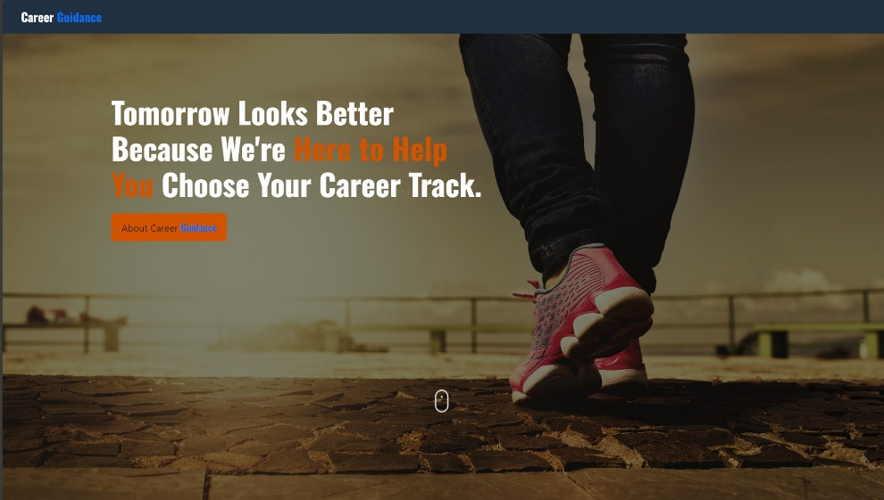

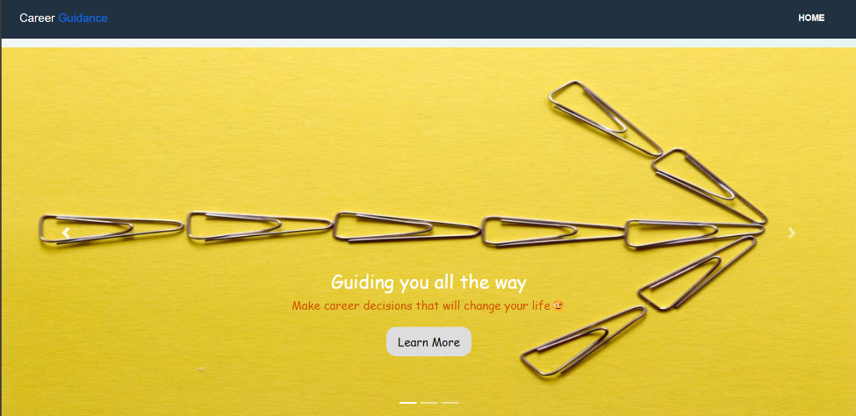

When users visit, they land on the main page of the platform. It acts as the entrance to different parts and features on the site.

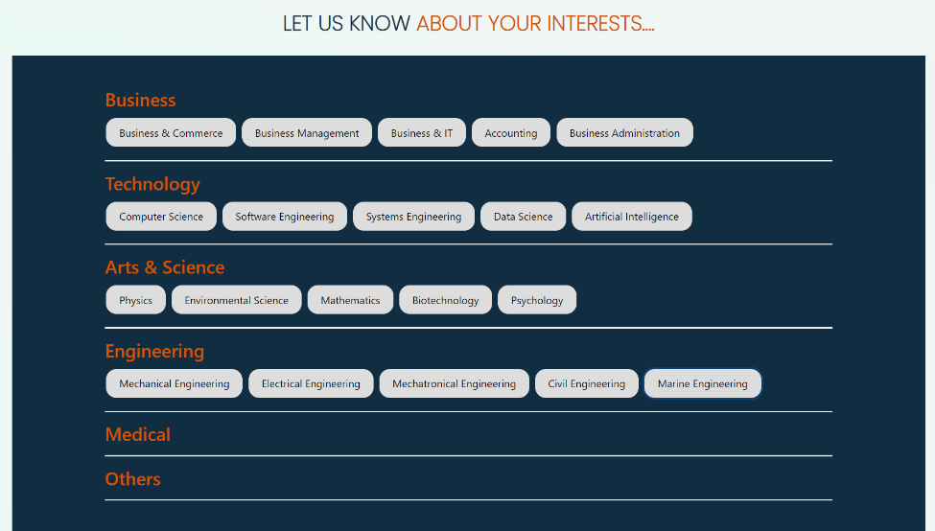

On the homepage, users click into the "Explore Careers" section. This page is all about giving information on different jobs, industries, and job possibilities.

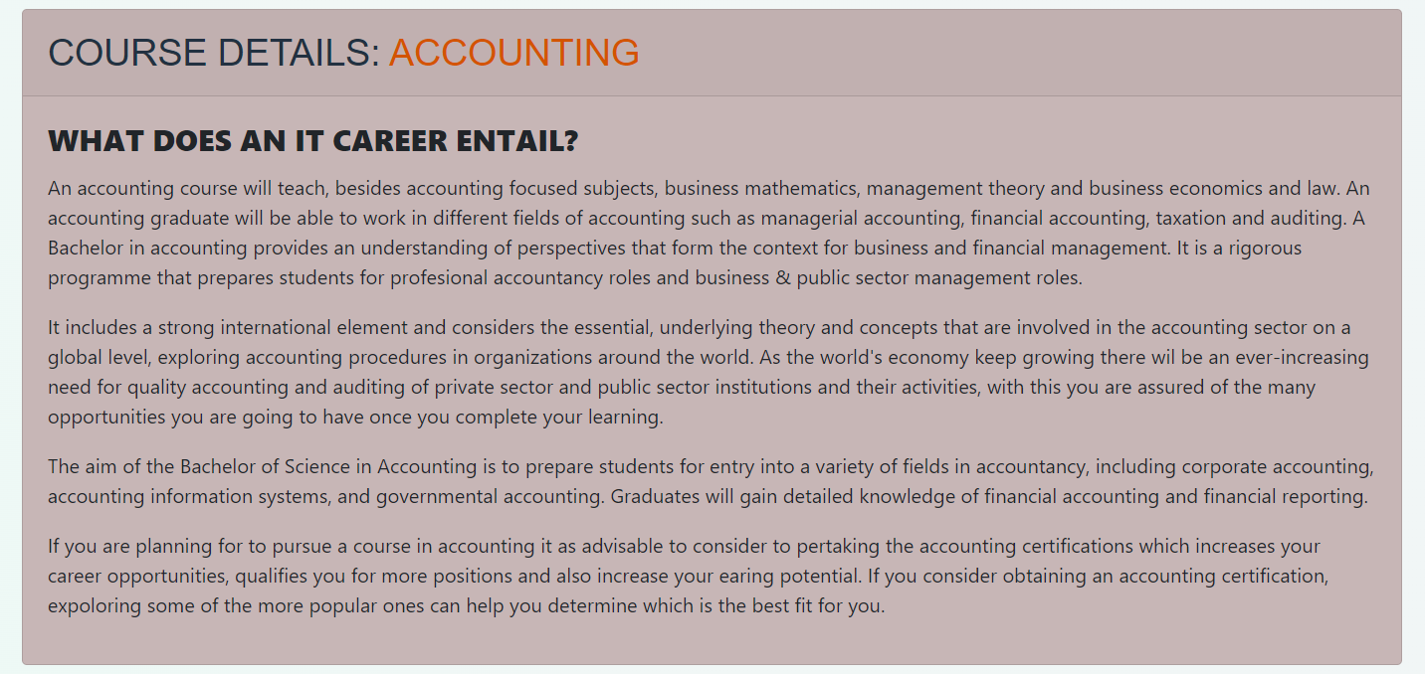

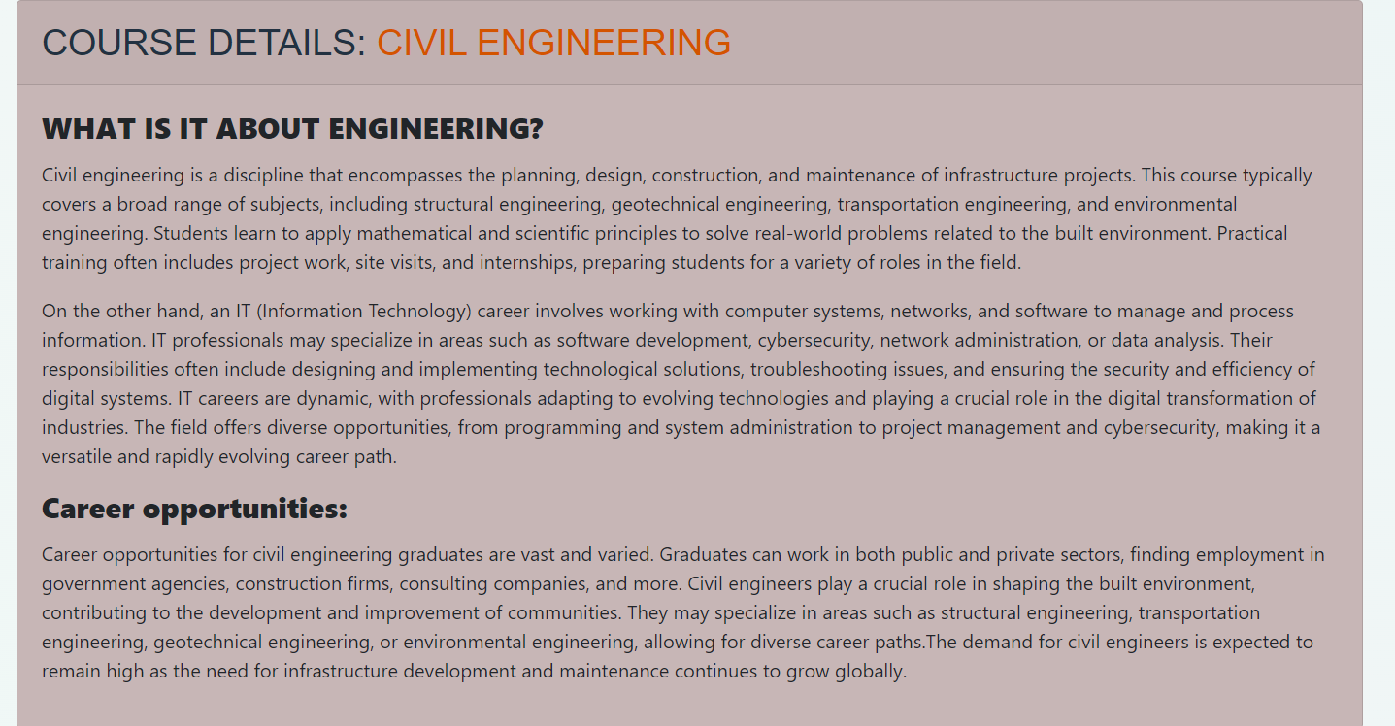

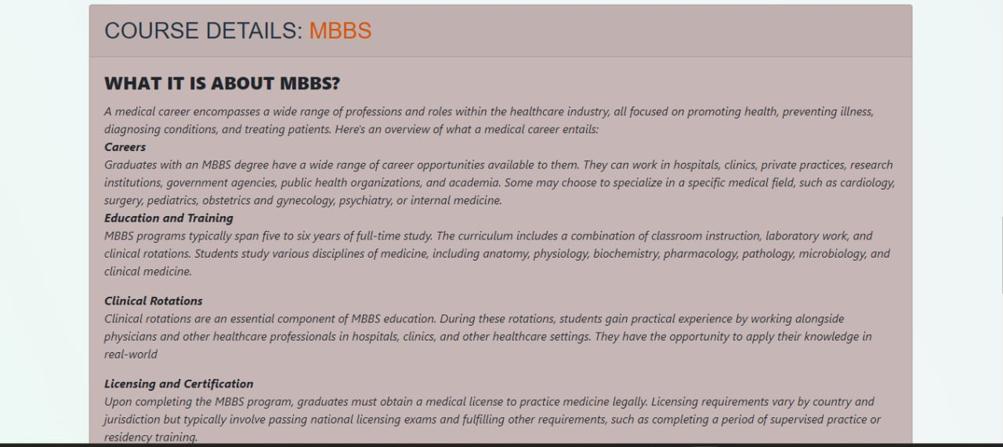

In the "Explore Careers" section, users can find info about particular courses linked to their chosen career paths. This includes details about what you'll study and other important facts about educational programs.

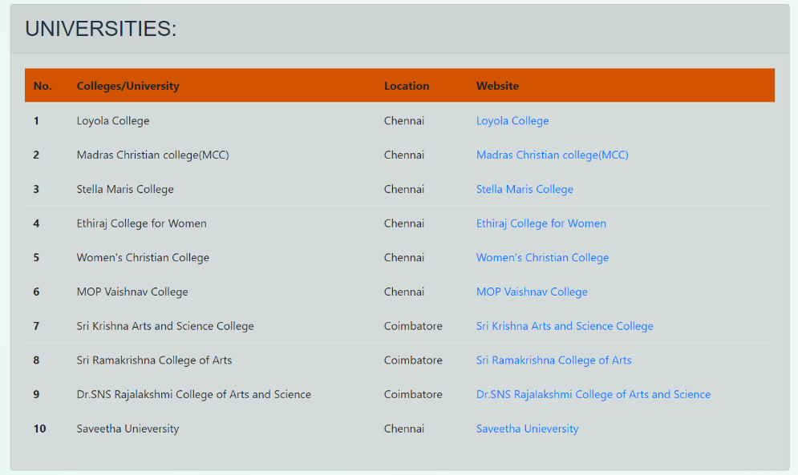

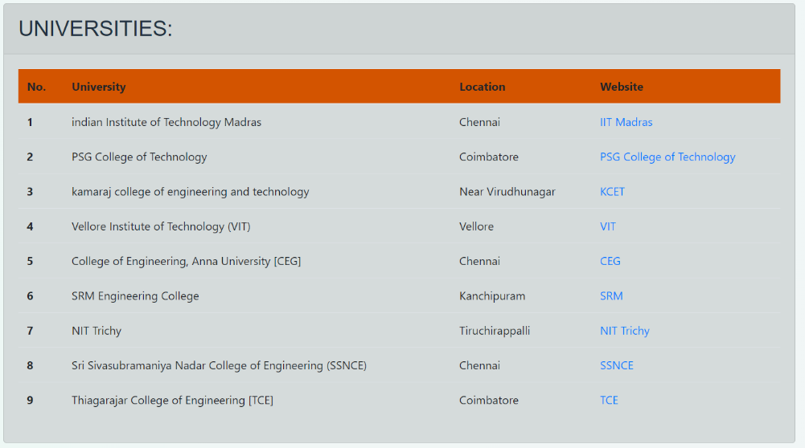

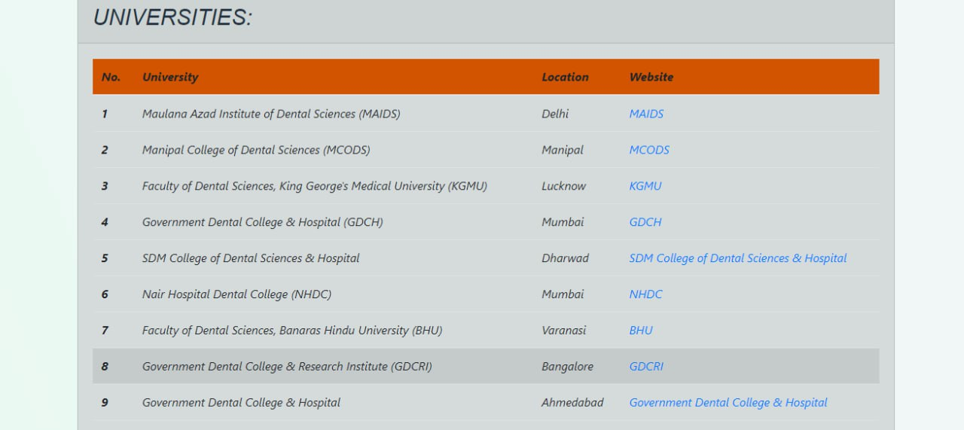

After users find a course they like, they can check out the best colleges or universities that offer that program. This part usually gives information about various educational institutions, helping users choose where to study based on informed decisions.

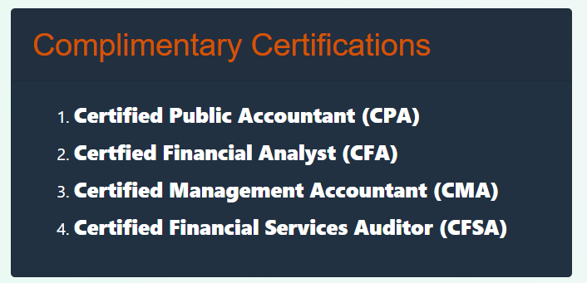

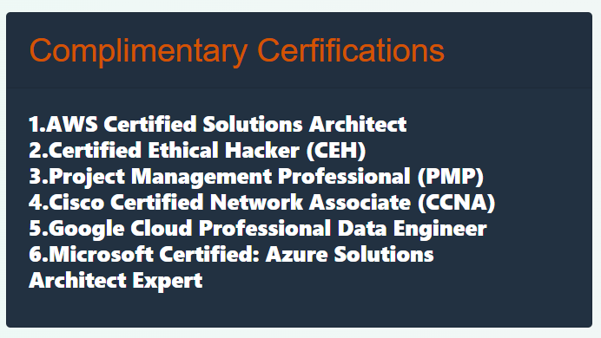

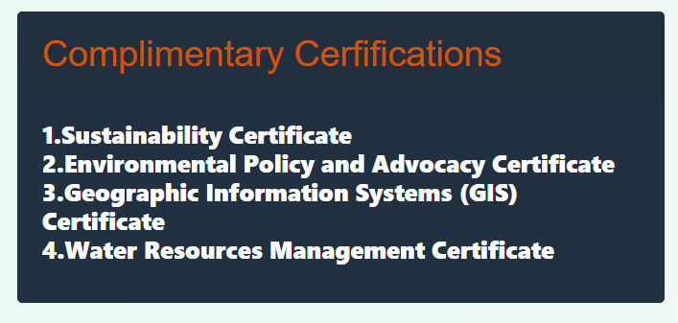

This section is where users can find extra materials related to their chosen career or education. These might include YouTube links or other information to help them learn more.

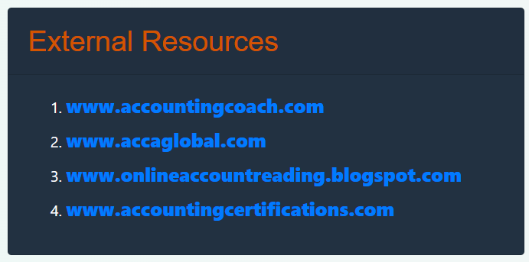

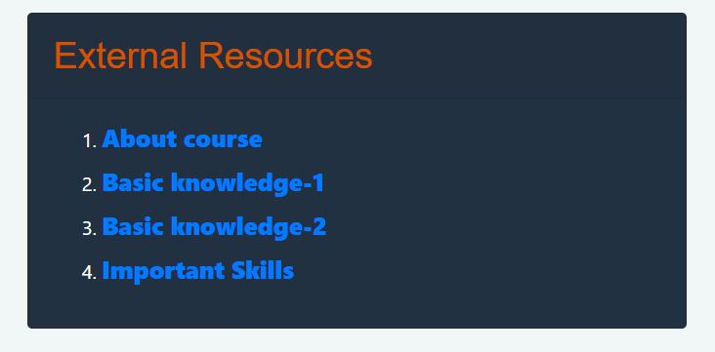

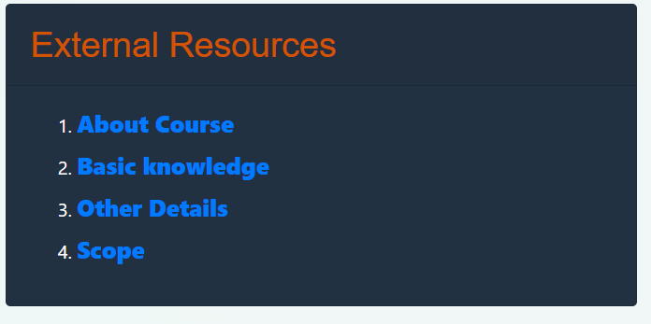

The last part of the process provides details about additional certifications that go well with the chosen course. These could be extra qualifications or certifications to enhance the learning experience.